1. Create a Bucket in IBM Object Storage

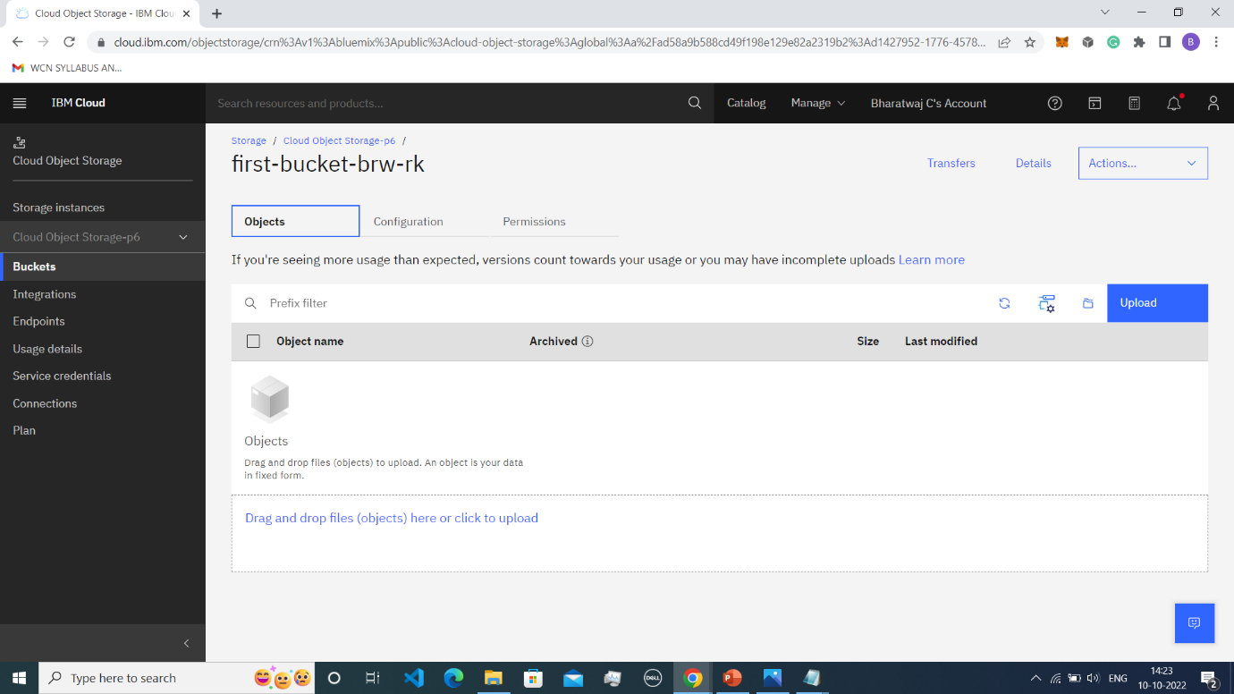

1. Upload an 5 images to IBM Object storage and make it public. Use HTML to display them

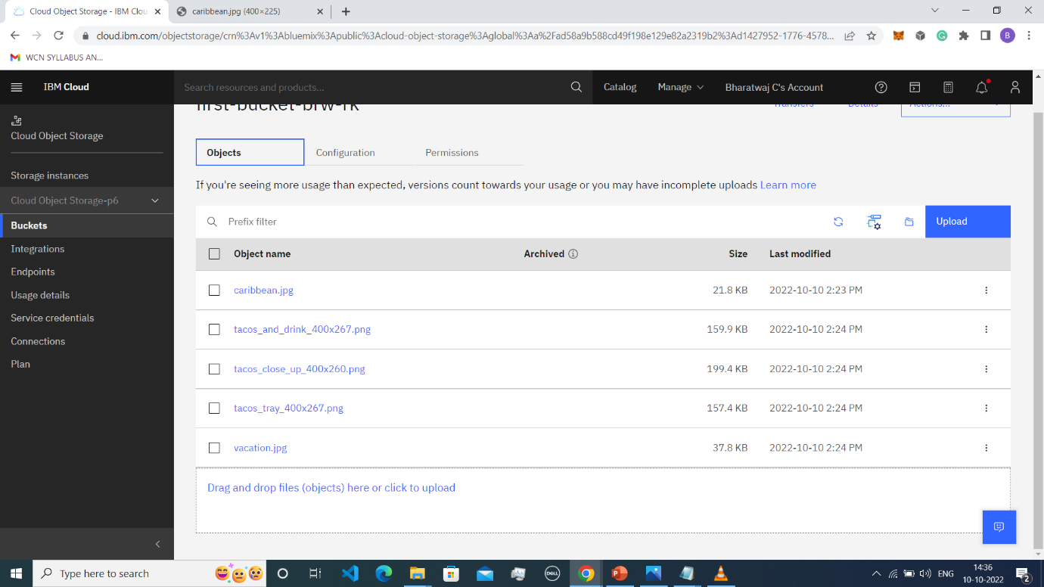

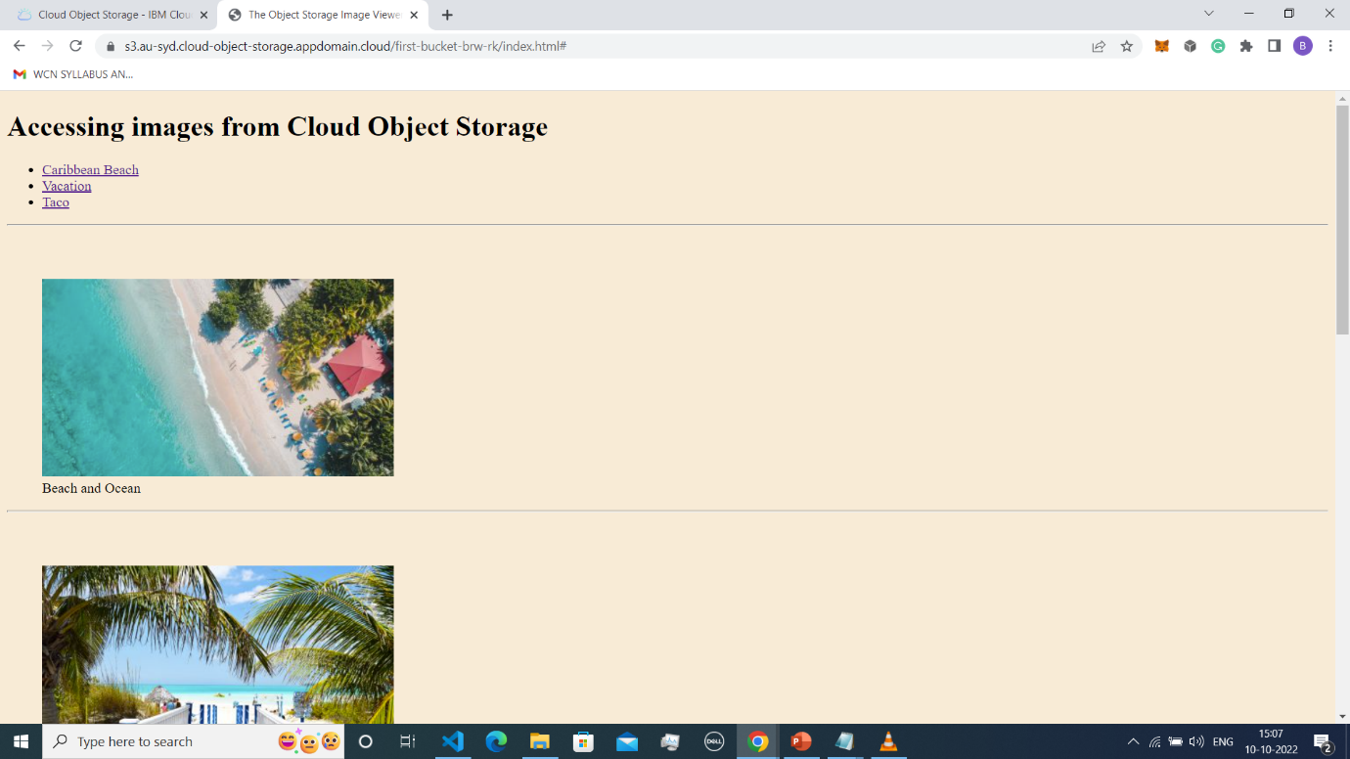

1. Upload a css inside you r object storage and use the code in your HTML Page

